Celebrating Pride Month 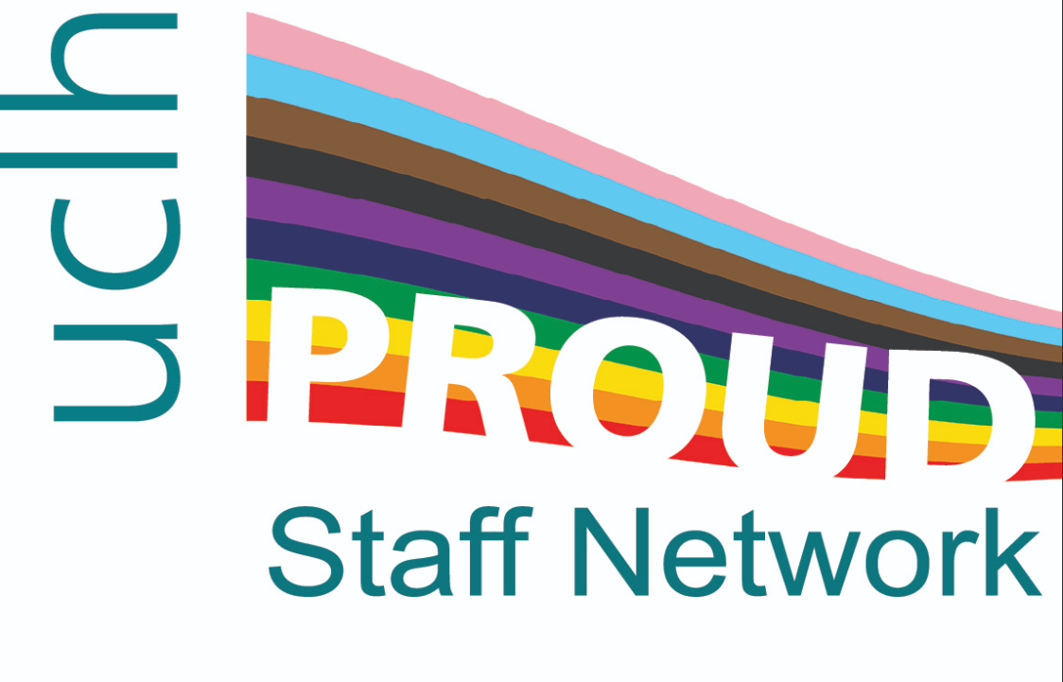

The hidden queer history of Fitzrovia: guided walk.

Fitzrovia: Wednesday 25th June 5:30-7:15

Slowly meander through the local area uncovering hidden LGBTQIA+ stories. Storytelling brings to life the hidden stories of trailblazers and scandals in a fun and interesting way.

Fitzrovia: Wednesday 25th June 5:30-7:15pm
Starting with a nod to the initiations of Molly houses of old we move on to meet artists, dancers, pop stars, royalty and a time lord. Moving on we see the site of one of the biggest queer scandals of Victorian London, and finally, via a shocked missionary finish at the Fitzroy Tavern, Charlotte Street.

The walk is free to attend and led by Clive Pankhurst. They start from the UCLH café at 250 Euston Road. All welcome, including allies.

To book a place on either walk email xxxxx.xxxxxxxx@nhs.net There is a maximum of 15 people on each one so it’s a first come first served allocation

