



Gloucester House The Tavistock Children’s Day Unit

Care and Control Policy and
Procedure

Reviewed by:
Last review: | May 2022
Next review date: | May 2023

 | Contents
Section |  |  | Page
l | Introduction |  | l-2
2 | Purpose |  | 2
3 | Scope |  | 2
4 | Definitions |  | 3
5 | Policy statements |  | 3
6 | Duties and responsibilities |  | 4
7 | Procedures |  | 5-7
8 | Training Requirements |  | 7
9 | Process for Monitoring Compliance with | the Policy | 7-8
10 | References |  | 8-9
l l | Associated documents |  | 9
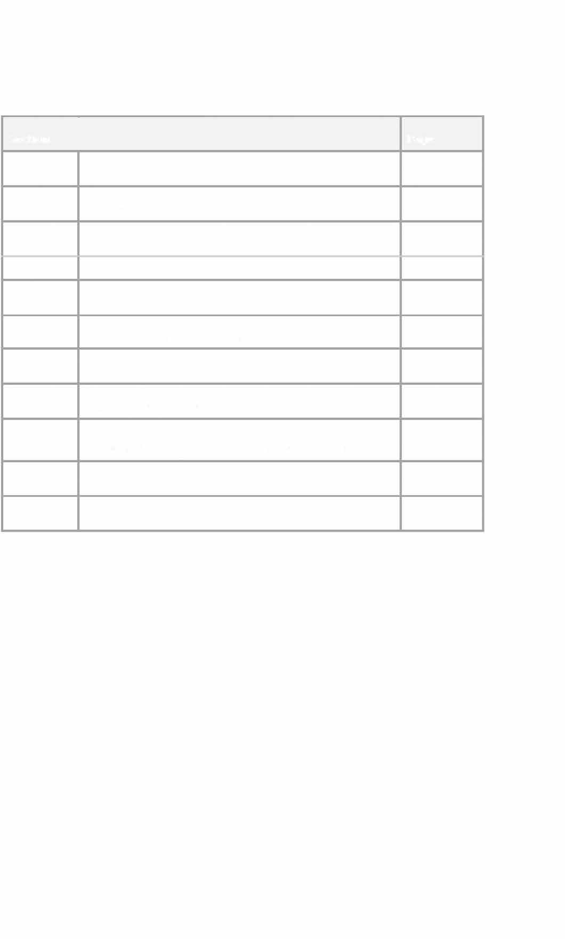

1 Introduction
This policy has been developed taking account of DfE guidance ‘Use of Reasonable Force in Schools’, the NICE guidance on ‘Violence and Aggression’ and the Team Teach system (see section 11 for references).

Gloucester House is a high risk setting by nature and there are occasions when physical management of pupils is appropriate and necessary. The Education and Inspections Act 2006 stipulates that reasonable force may be used to prevent a pupil from doing, or continuing to do any of the following:
- self – injuring
- causing injury to others
- committing a criminal offence
- engaging in any behaviour prejudicial to maintaining good order and discipline at the school or among any of its pupils, whether the behaviour occurs in a classroom during a teaching session or elsewhere within school (this includes authorised out-of-school activities).

We also recognise that children who exhibit this level of behaviour need a clear and structured framework for behaviour management including physical containment. There are a number of restraint frameworks but we have chosen Team Teach for its ethical and holistic approach as much as its clear framework for restraint procedures and emphasis on ongoing efforts to reduce use of physical intervention.
Team Teach offers a holistic teambuilding approach to enable individuals and organisations to develop a full range of effective and flexible supports and encouragements for children and adults who exhibit challenging behaviour.

Team Teach emphasises a spectrum of gradual and graded responses to reduce the probability of challenging behaviour escalating towards violence. The emphasis is always on preventive measures, diffusion and de-escalation. As a high risk setting, we aim, within a framework, only to physically contain safely when necessary.


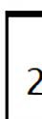
Physical techniques and restraint are always a safeguard and never a sanction.

We include positive physical contact (contingent touch) within this policy as is important to emphasise that physical contact also has a positive role in containment. Positive Physical Contact (contingent touch):

Staff need to be aware of sensitivities of any form of physical contact with pupils. Contact between children and adults might be appropriate for a variety of reasons, including:

Calming/reassuring/comforting contact
- A gentle touch on the arm to re-focus attention
Guiding (without force) a pupil away from a situation or location.

Any physical contact has to be managed in order to make sure that it is appropriate and leaves neither party vulnerable to allegations of abuse. Factors to consider might include:

Knowledge of the child, e.g. history/background
- Age (and age difference) - of child and adult Context - where, when, why
Relationship between staff member and child Gender

Purpose

As part of its behaviour management Gloucester House recognises that good personal and professional relationships between staff and pupils are vital to ensure good order in Gloucester House.

Gloucester House has a strong focus on PHSE to help children to learn about feelings and managing conflict, where this is appropriate to their level of development. Gloucester House's curriculum and ethos promote independence, choice and inclusion and children are given maximum opportunity for personal growth and emotional wellbeing.

This policy clarifies when and how force and control may be used. It is also acknowledged that staff may need to take action in situations where the use of reasonable, proportionate and necessary force may be required. Gloucester House acknowledges that physical techniques are only a small part of a whole setting approach to behaviour management. This policy also describes when and how staff may use contingent touch.


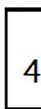
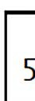
3
Scope:

This procedure applies to Gloucester House.

Definitions

Physical Interventions (Holds): These are devised to allow staff to be strong in presence but gentle with their touch. The principles of biomechanics are part of all physical interventions to reduce reliance on power and strength. (See team teach manual)

Restraints: is reserved for an intervention that results in a pupil being totally overpowered. Physical intervention, resulting in restraint can be both exhausting and a distressing experience for children and staff. Staff and children should be provided with a support process which allows for reflection, repair, and change.

Contingent touch: calming, reassuring, comforting contact (see section in introduction)

Policy Statements

The application of any form of physical control inevitably carries an attached risk of unintended harm and this places staff and the school at risk of potential litigation. It can only be justified according to the circumstances described in this policy. Staff, therefore, have a responsibility to follow this policy and to seek alternative strategies wherever possible in order to prevent the need for physical intervention. Staff need to be aware that they are responsible for:


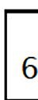
Assessing risks (dynamic risk assessment) related to individual circumstances which may arise in the course of their day-to-day duties.
Making judgements about when the use of force is necessary and the degree of force which may be regarded as proportionate to manage a situation.
Remaining mindful that physical interventions are never a sanction and always a safeguard.
Whilst the physical techniques are intended to reduce risk, there is always risk when two or more people engage to use force to protect, release or restrain. Team Teach techniques seek to avoid injury to the service user, but it is possible that bruising or scratching may occur accidentally, and these are not to be seen necessarily as a failure of professional technique, but a regrettable and infrequent side effect of ensuring that the service user remains safe. Any such injury will be reported using the Incident Reporting system. Any injuries to pupils as a result of incidents involving restraint will be reported in line with locally agreed LADO procedures, as indicated.

In addition procedures are in place to ensure that appropriate support is provided for staff and that following an incident pupil/staff relationships are rebuilt and repaired to ensure that a positive learning environment is maintained.

Duties and responsibilities

The Head Teacher is responsible for ensuring that the Team Teach framework and training requirements are adhered to in order to safeguard staff and children.
The Team Teach trainer shall ensure that all staff are trained in skills to help them to defuse situations before behaviour becomes challenging and how to de-escalate incidents should they arise. They also ensure that staff are trained in appropriate physical management skills and techniques.
The Clinical Nurse Specialist monitors the use of holds and restraints. This is shared regularly with the Health and Safety officer. All staff need to be aware that they are responsible for:

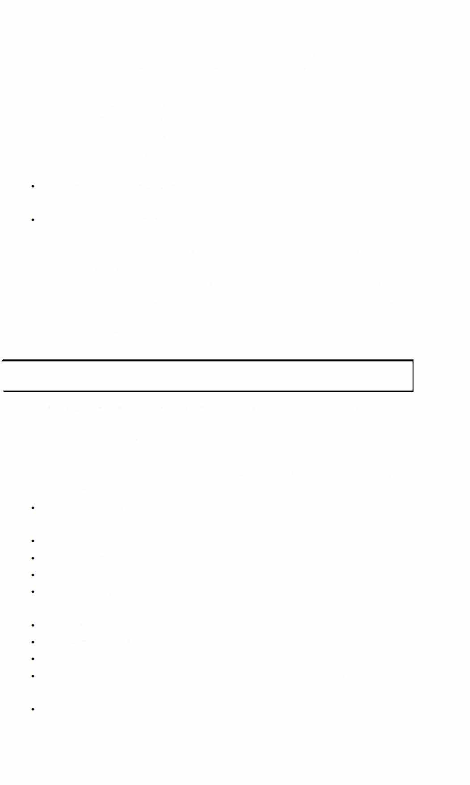
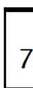
- assessing risks (dynamic risk assessment) related to individual circumstances which may arise in the course of their day-to-day duties and
- making judgements about when the use of force is necessary
and the degree of force which may be regarded as proportionate to manage a situation
- Recording holds and escorts on day sheets.

Staff need to be aware of Positive Handling Plans and consider these when working with children.
During the assessment period all new children and families are informed of our Care and Control Policy and Procedures for physical management. At Gloucester House we work in partnership with service users and carers. The class teacher in conjunction with the child, parent/carer and case coordinator will draft a Positive Handling Plan. These are updated regularly and shared with all new staff as well as social workers and the wider professional network around the child.

Procedures

Where staff decide physical intervention is necessary, it is important that it happens quickly, smoothly, confidently, and under considered, calm, control of the members of staff involved.

Staff will need to make a dynamic risk assessment of the situation and this will involve a number of considerations:
The children's characteri stic ways of responding to stress and authority
The known intention of the child Personal history
The current context
Knowledge of the chi ld's performance, includi ng the Gloucester House education, health and care plans and PHPs
Age
Level of understanding Cultural influences
Whether the chi ld is taki ng prescri bed medication or under the influence of drugs
Whether there is a weapon involved

- The availability of other staff
- The presence of other children
- The confidence, competence and self-control of the staff involved

Key Points
- Staff are expected to exhaust all behavioural management strategies, where possible, before using any physical intervention.
- Staff should be aware of current Positive Handling Plans for all children and contribute to these.
- The force used should be the minimum necessary to control the situation. It should be reasonable and defined by the circumstances.
- Staff should not act alone when assistance is available when carrying out a physical intervention.
- Staff have a duty of care to themselves as well as to the pupils.
- A risk assessment should be made of the situation and a balanced and appropriate decision made. Restraints/holds are recorded on the day sheet, monitored and shared weekly.
- De-brief provides a space for staff to acknowledge the impact of difficult behaviour on themselves. It also provides a supervised space for recording holds/restraints. It is a meeting where managers can monitor impact and offer further space for staff who need it. Staff also use this space to identify children that may need follow- up meetings the following day.
- Following a restraint the Restraint Log book is filled in by all members of staff involved. This includes post incident discussions. These logs are monitored by the Head Teacher weekly.
- Front, Ground and Recovery (FGR) holds are currently not used in Gloucester House. If it is felt that this level of physical intervention is helpful or necessary, staff would need to be trained accordingly. Permitted:-
- All de-escalation techniques as outlined by Team Teach in addition to other therapeutic and behaviour management strategies.
- Any intervention that is able to be justified as reasonable and proportionate in exceptional circumstances.
- All the physical strategies as described and practised in the Team Teach manual (in accordance with the level of Team Teach training the individuals have completed).

Not Permitted:-
- Intentional or malicious pain inflicted on a pupil. It is accepted that on some occasions, it is impossible to take action without causing

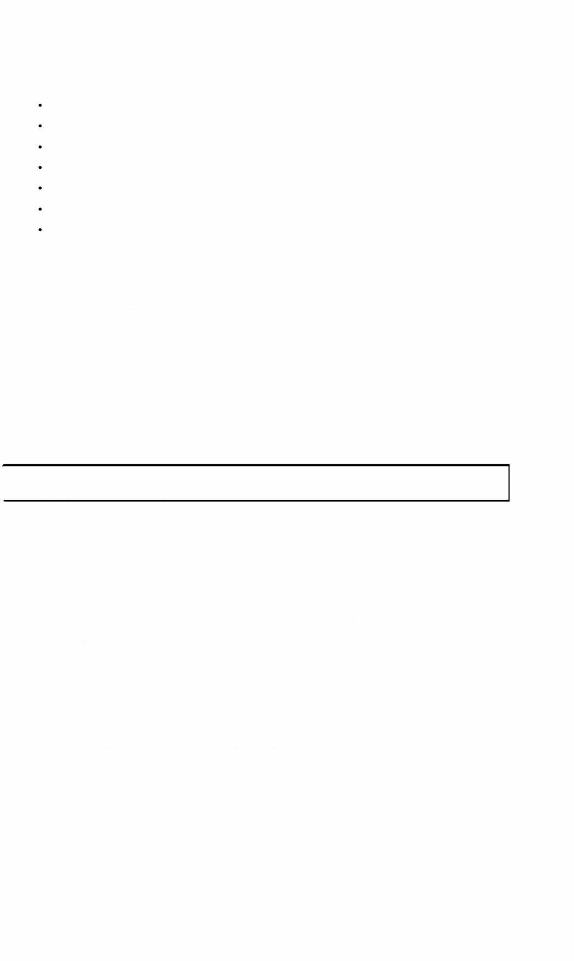
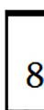
discomfort. Any pain caused will be accidental and is not used as a means of control
Using restraint as a punishment Hitting a pupil
Forcing a pupil's arm behind the back Twisting limbs
Sitting on a pupil
Any restraint which restricts circulation or breathing
Any holding that could reasonably be interpreted as being sexually invasive

All physical management situations should embody the post incident structure as described in Team Teach. The aim of this is to go back and discuss issues that provoked a violent episode and get the child/staff to reflect on the incident.

Staff must enable pupils to realise and learn that there are acceptable and appropriate ways of managing feelings and dealing with situations without resorting to violence and/or serious disruption.

Training Requirements

The Team Teach trainer ensures that all staff in Gloucester House:

- Clearly understand this policy and their responsibilities in the context of their duty of care in taking appropriate measures where use of force is necessary and
- Are provided with appropriate training to deal with these difficult situations.
- Provide training on Team Teach methods to educational, clinical and admin staff.

Courses are as follows:
- 6 hour courses are appropriate for some staff - e.g. child psychotherapists in training will attend at least 6 hours and more if this fits with their other commitments. Visiting sessional therapists and administrative staff may attend but it is not a requirement.
- All teachers, Progress Support workers (PSW's) and clinical staff who spend substantial time in Gloucester House attend 12 hour basic Team Teach courses

as soon as is practical after appointment: If it is required some staff will be given further training in advanced techniques.
- Training will be via Inset days, group refresher sessions, and problem solving discussions.
- Training is reaccredited every 12 - 15 months for Advanced Team Teach Tutors, if deemed necessary.
- PSWs, teachers, and clinical staff are reaccredited at least every 24 months with regular refreshers. Gloucester House often run courses more frequently- between 12 – 18 months. This is good practice and ensures new staff are trained.
9 Process for monitoring compliance with this policy/procedure
  - Day sheets/incident report forms/log book are how we record holds and incidents. These are monitored weekly and the data is shared through a weekly spreadsheet.
  - Staff identify trends in the monitoring which can then be addressed for individual or group behaviour causing concern.
  - Follow-up after de-brief and morning briefing the following day provides a space and opportunity to ensure follow-up for children and staff is arranged.

Holds/Restraints:
  - Holds/restraints are recorded daily on the day sheet.
  - Restraints are recorded in the restraint log book by all staff involved and are shared with parent/carers and monitored by the Head Teacher.
  - All holds/restraints are monitored weekly by the Deputy Head Teacher and shared with staff and Case Co-ordinators to identify patterns or concerns.
  - Incident forms are monitored regularly by the Deputy Head teacher. These are then shared with Health and Safety committee and Case Co-ordinators.
  - Holds/restraints are also monitored on a termly basis. The range of monitoring techniques ensures we tackle both strategic issues and individual issues. We can then deal with concerns on a strategic basis through whole team meetings, child reviews, SEF, individual risk assessments, positive handling plans, daily targets, Gloucester House education, health and care plans targets and further Team Teach refreshers.

Risk assessments are written for all children and additional risk assessments are done for those who present a particular risk and for OSV (Off Site Visit).



I i o

I i I
Positive Handling Plans:
Positive Handling Plans are reviewed termly by staff and discussed at Inset days and whole team meetings. These are also shared and signed by parent/carers and the children.
Positive Handling Plans are also reviewed following serious incidents or concerns about the number of restraints/holds used.

References

'Use of Reasonable Force'-Advice for teachers, staff and governing bodies 2013 (reviewed 2015) https://www.gov.uk/qovernment/publications/use-of­ reasonableforce-in-schools
Nice Guidelines: Violence and aggression: short-term management in mental health, health and community settings (NGl O May 2015) specifically l.7 Managing violence and aggression in children and young people
http: //www.nice.orq.uk/quidance/NGl Ofchapter/l recommendatio ns#managing-violence-and-aggression-inchildren-and-young­ people-2
- Violent and aggressive behaviours in people with mental health problems
Quality standard [QSl 54] Published date: June 2017 https://www.nice.orq.uk/guidance/gs l54

- Team Teach System https: //www.teamteach.co.uk/

Associated documents

The Education and Inspections Act 2006
DOH/DFES Joint Guidance on Physical Interventions Uuly 2002) Children's Act 1989
The Education Act 1996 Gloucester House Behaviour Policy
Gloucester House staff wellbeing policy Health & Safety Policy

Risk Assessment Policy
Working Together to Safeguard Children (Feb 2019)
DFE guidance – Use of Reasonable Force in Schools (July 2013)
The Deprivation of Liberty Safeguards as part of Mental Capacity Act (2005, Mental Capacity (Amendment) Act 2019)
Nice Guidelines: Violence and aggression: short-term management in mental health, health and community settings (NG10 May 2015)
Keeping Children Safe in Education – September 2021
Guidance to Tackle Restraint- positive and proactive care (September 2014 –
CQC)
Behaviour and Discipline in schools – January 2016
Positive environments where children flourish OFSTED March 2019 Reducing the Need for Restraint and Restrictive Intervention (DfE 2019)

